# Using Eclipse & Submitting Files

Throughout this course, you will be writing code and submitting it to your instructor. In today’s lesson, we will review the procedure to:

* open Eclipse
* set up a workspace
* create a file
* save a file and eject your USB safely

Eclipse Procedure Overview

Each of the following steps is explained in detail on the following pages. As you repeat the steps, you will become more familiar with them, and so we’ve offered this quick reference guide so that you can check the steps quickly and easily in the future.

*Plug In Procedure Un-Plug Procedure*

1. Turn on your computer 1. Save all
2. Log into student account 2. Exit Eclipse
3. Insert USB drive 3. Safe-eject USB drive
4. Launch Eclipse using the thumbnail 4. Remove USB drive
5. Set Workspace to F:\
6. Enter Workbench
7. Create new Java Project
8. Create new Java Class

Plug In Procedure

**Content  
Collaboration Tools for programming**

In this activity you will learn the correct procedures for using a USB drive to store and transport your programs. The USB drive also provides an opportunity for you to collaborate with others and share your programs.

Can you think of other ways that you might collaborate with others in this course as you create and share programs? What methods are used in the field of programming when there are a number of programmers working on developing the same software application?

Turn on & Login

1. Turn on the computer and wait for it to power up.
2. If prompted for login, your teacher will give you your username and password. Record your username and password here for safekeeping:

username: password:

Insert USB Drive

1. Insert USB drive
2. Some Windows messages might appear—ignore them.

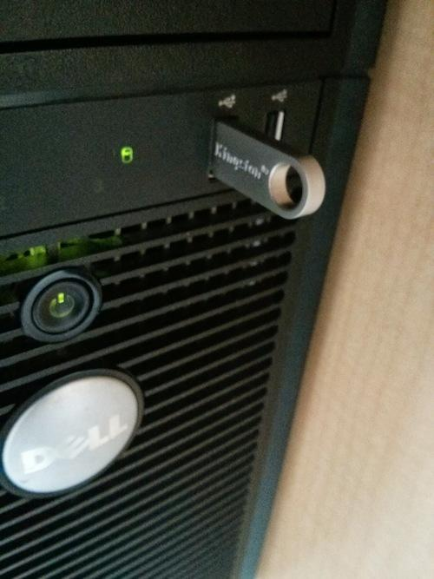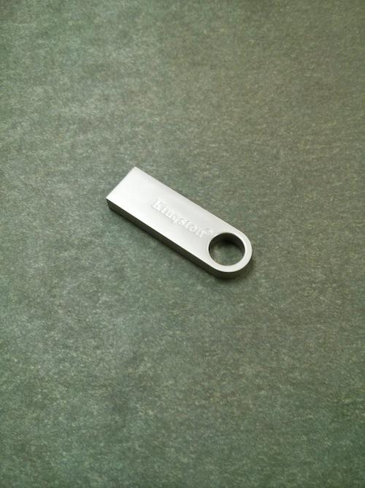

Start Eclipse & Workspace

1. Double-click on the Eclipse Icon on the desktop
2. Type F:\ as the Workspace location. The \ character can be found near the return key on the upper right section of your keyboard.

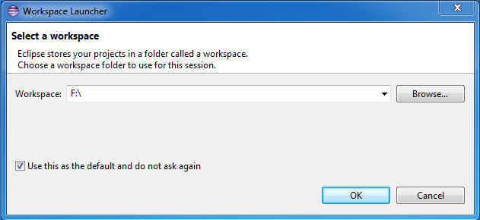

Click “Use this as the default” and then click on OK.

Enter Workbench

1. Double-click on the Eclipse Icon on the desktop

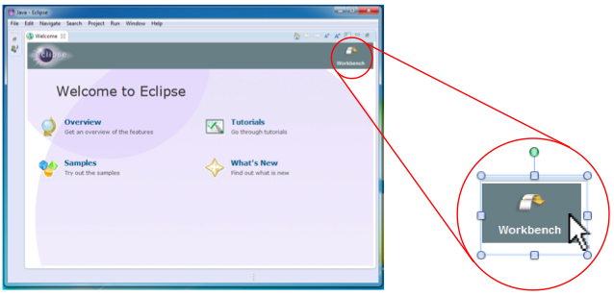

Create New Project

1. Create a new Project with File > New > Java Project.

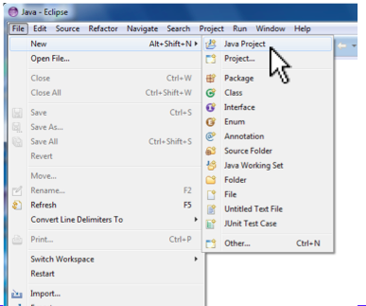

1. Fill in the project name, then click on Finish.
   1. *The Project Name will usually be given to you by your teacher; in general you should name your project something descriptive (instead of “Project One”) to help you find it later.*

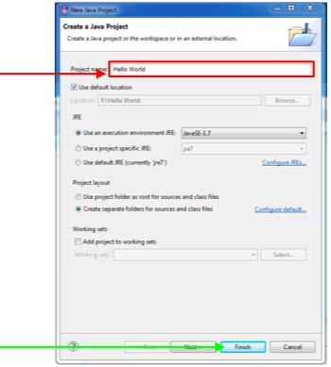

Create New Java Class

1. Right-click your Project and select New > Class.

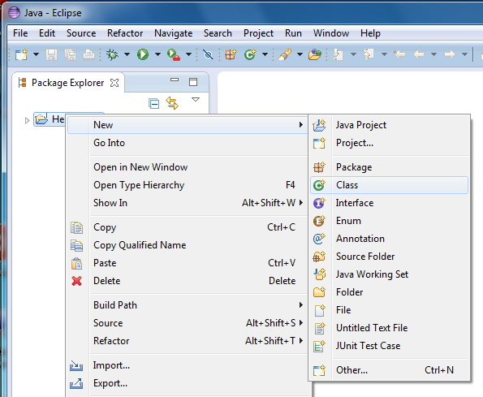

Right click here

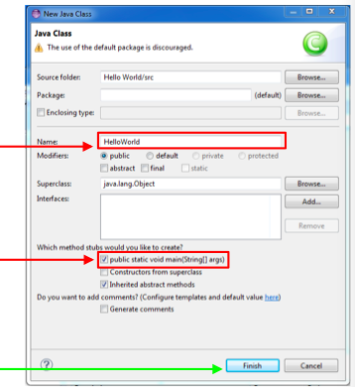

1. Enter Class name (only letters

a-z and A-Z).

1. Click to create a main() method
2. Click Finish

Running Your Program

1. Type the following line of code after // TODO Auto-generated method stub

System.out.println (“Hello, world.”);

1. Save file with Ctrl-S
2. Click on the Run Icon
3. Look for output in the Console Window.

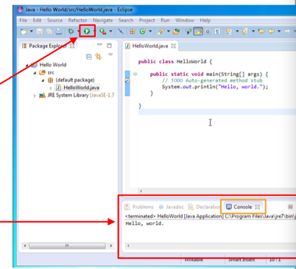



Un-Plug Procedure

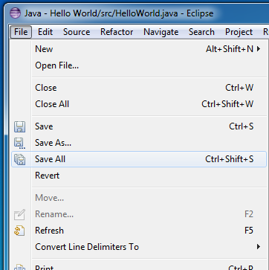

Save All

1. Click on File > Save All to

save all edited files.

*This text might be greyed-out*

*and not-clickable if all files*

*have already been saved.*

Exit Eclipse

1. Select File > Exit

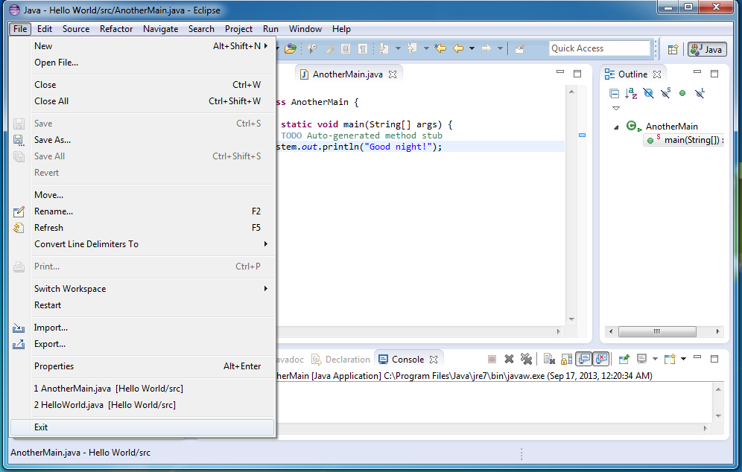

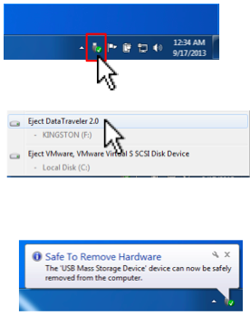Safe-Eject USB Drive

1. Click on the Devices icon in the

lower-right corner of the screen.

1. Select Eject Data Traveler
2. Wait for Safe to Remove Hardware

message.

Remove USB Drive

6. Remove the USB Drive from the Computer. Don’t forget to take it with you, and be sure to bring it back to class each day!

